**DESIGN AND IMPLEMENTION OF A COMPUTERIZED PENSION VERIFICATION SYSTEM**

**(A CASE STUDY OF OSUN STATE PENSION BOARD)**

**BY**

**OIBOH JOHNSON JUNIOR 14/CSH/0607**

**&**

**OLOJEDE ADEBIMPE RACHAEL 14/CSH/0612**

**BEING A PROJECT WORK SUBMITTED TO THE DEPARTMENT OF COMPUTER SCIENCE, FACULTY OF INFORMATION AND COMMUNICATION TECHNOLOGY,OSUN STATE POLYTECHNIC, IREE**

**IN PARTIAL FULFILMENT OF THE REQUIREMEN FOR THR AWARD OF HIGHER NATIONAL DIPLOMA (HND) IN COMPUTER SCIENCE, OSUN STATE POLYTECHNIC, IREE**

**DECEMBER 2016**

**ACKNOWLEDGEMENTS**

God, you are the pillar that holds our life, so, we are acknowledging you for who you are in our life’s, for what you have done and for being our source of energy and wisdom right from the beginning of our studies to the completion stage, all adoration belongs to you.

We humbly and sincerely appreciate the effort of our supervisor, Mr Oduwole O.A for his fatherly support, suggestion and finding time to correct some mistake for the success of our project.

Also to Mr Oladoye S.F. HOD computer science department and all the lecturers in the department who has planted in us the knowledge and experience that we needed to become a notable and a future programmer in life. To you all we say thank you.

Our deepest appreciation goes to our wonderful and lovely parents Mr. and Mrs. Oiboh and Mr. and Mrs. Olojede for their financial support, love, care and their effort laid on us to make us great and for their parental role on us since birth to where we are now, may Almighty God continue to bless them and we pray that they will live long to eat the fruit of their labour (Amen).

Finally, we express our heartfelt thanks to our friends and all those who stood and helped us during the course of our academic pursuit, To you all we say thank you.

**CERT IFICATION**

This is to certify that this project work was carried out by **OIBOH JOHNSON JUNIOR** with matriculation NO**: 14/CSH/0607** and **OLOJEDE ADEBIMPE RACHAEL** with matriculation NO: **14/CSH/0612** in the Department of Computer Science, Faculty of Information and Communication Technology, Osun State Polytechnic, Iree, Osun State in partial fulfillment of the requirements for the award of Higher National Diploma (HND)

**____________________ ______________________**

**Mr Oduwole O. A. Date**

**Project Supervisor**

**____________________ ______________________**

**Mr Oladoye S.F. Date**

**Head of Department**

**CERTIFICATION**

This is to certify that this project work was carried out by **OIBOH JOHNSON JUNIOR** with matriculation NO**: 14/CSH/0607** in the Department of Computer Science, Faculty of Information and Communication Technology, Osun State Polytechnic, Iree, Osun State in partial fulfillment of the requirements for the award of Higher National Diploma (HND).

**____________________ ______________________**

**Mr Oduwole O. A. Date**

**Project Supervisor**

**____________________ ______________________**

**Mr Oladoye S.F. Date**

**Head of Department**

**CERTIFICATION**

This is to certify that this project work was carried out by **OLOJEDE ADEBIMPE RACHAEL** with matriculation NO: **14/CSH/0612** in the Department of Computer Science, Faculty of Information and Communication Technology, Osun State Polytechnic, Iree, Osun State in partial fulfillment of the requirements for the award of Higher National Diploma (HND).

**____________________ ______________________**

**Mr Oduwole O. A. Date**

**Project Supervisor**

**____________________ ______________________**

**Mr Oladoye S.F. Date**

**Head of Department**

**TABLE OF CONTENTS**

Title page i

Certification ii

Dedication iii

Acknowledgment iv

Table of Contents v

Abstract vi

**CHAPTER ONE**

1. Introduction

1.1 Background of the Study

1.2 Statement of the Problem

1.3 Aim and Objectives of the Project

1.4 Significance of the project

1.5 Scope of the Project

1.6 Research Methodology

1.7 Definition of Terms

**CHAPTER TWO**

2.0 Literature Review

2.1 General Overview

2.2 Legal Frame Works of Pension in Nigeria

2.3 Record Management and Administration of Pension in Nigeria

2.4 Problems Associated With the Present Records Management

2.5 Features of Old Pension Scheme (Defined Benefit Scheme)

2.6 The National Provident Fund Scheme of 1961

2.7 The Contributory Pension Scheme of 2004

2.8 Pension Schemes in Developing Countries

2.9 The Role of a Broker/Consultant in the Pension Scheme

**CHAPTER THREE**

3.0 Research Methodology

3.1 Research Approach

3.2 The Description of the Developed of a Computerized Pension Verification System

3.2.1 The Admin Login Page

3.2.2 Pension Enrolment Form

3.2.3 Pensioner Verification Form

3.2.4 Pension Monthly Verification Form

3.2.5 Monthly Verification Form

3.2.6 Pension Monthly Verification Report

3.2.7 Pension Payment Information Report

3.2.8 General Pension Enrolment Report

3.3. System Implementation

3.3.1 System Evaluation

3.3.2 Evaluation Criteria

3.3.3 Evaluation Methodology

**CHAPTER FOUR**

4.0 Results and Discussion

4.1 Result

4.2 Discussion

**CHAPTER FIVE**

5.0 Conclusion and Recommendation

5.1 Conclusion

5.2 Recommendation

**REFERENCES**

**ACKNOWLEDGEMENT**

All praises is due to Almighty God for his mercy, sanctifying blessing and without whose assistance the project and this course would not have been successful.

My appreciation also goes to my supervisor Mr. Oduwole O.A, for his enduring patient and taking the burden to the project.

I also appreciate the effort of my H.O.D, Mr. Oladoye S. F. and all other lecturers in Computer Science Department for the knowledge imparted on me. Thank you all.

My gratitude also goes to my wonderful parents for their care and support, morally, spiritually, physically and financially may you live long to eat the fruit of your labour (Amen).

I will also like to say a big thanks to my project partner in person of OLOJEDE ADEBIMPE RACHAEL for the cooperation between us, may God be with you (Amen)

Finally, I would like to express my heartfelt thanks to my brother and sisters, Oiboh Segun, Omolola, Victoria, I love you all.

**ACKNOWLEDGEMENT**

My immerse gratitude goes to Almighty God for giving me the knowledge and strength to produce this project work, may his Holy name be glorified.

I am greatly indebted to my parent Mr. and Mrs. OLOJEDE, My guardian , my brothers and sisters in person of mayowa, Bose, Bunmi, Gbenga, Segun and Israel for their encouragement and support. In particular, I wish to thank my project supervisor Mr. Oduwole A. O who through every aspect of my work gave me appreciate guidance and support.

My appreciation also goes to my project partner in person of OIBOH JOHNSON JUNIOR for his co-operation and to my Head of Department Mr. Oladoye S. F and to all other lecturers for their immense contribution from beginning to the end, And also to all final year students of Department of computer science. May God bless you all.

**DEDICATION**

This project work is dedicated to the glory of God Almighty who existence is beyond human comprehension, the rock of ages, The beginning and the end. He that spared our life throughout our academic career.

**ABSTRACT**

Pension generally is a way of catering for the welfare of retirees. It is a periodic income or annuity payment made at or after retirement to employees who has become eligible for benefits through age, earnings and service. Pension verification system is a way of enrolling and verifying the pensioners. Investigation has revealed that there is no effective system for resolving the problem associated with the way of verifying pensioners of Osun State workers. Therefore a computerized pension verification system that is capable of efficiently verifying pensioners was designed, implemented and evaluated in this project.

The developed system was designed to be made up of, The Admin Login Page, Pension Enrollment Page, Pension Verification Page, Pension Monthly Verification Page, Monthly Verification Page, Pension Monthly Verification Report Page, Pension Payment Information Report Page interfaces. The developed system was implemented using Microsoft Visual Studio 2010 and c#.net. The performance evaluation of the system was carried out by administering questionnaire on thirty users after which the completed copies was collected and used for result analysis.

The result of evaluation of the developed system showed that 26 out of 30 users agreed that the system is usable. Also 26 out of 30 users agreed that the system is accessible. It is then concluded that in this work a computerized pension verification that is capable of ensuring speedy and accessible means of verifying Osun State pensioners has been developed.

**CHAPTER ONE**

1. **INTRODUCTION**

The management of Pension Fund in Nigeria is as old as Nigeria itself. Pension fund was introduced by the colonial masters to provide income and security for old age British citizens working in Nigeria upon retirement as a post-retirement benefit to employees. In the view of Adesina (2006:7), Nigeria Legislative instrument on pension matters was the pension ordinance of 1951 which had retrospective effect from 1st January, 1946. In 1961 National provident from (NPF) scheme was established with the legislation to address pension matters n private organizations.

Pension generally is a way of catering for the welfare of retirees. It is a periodic income or annuity payment made at or after retirement to employees who has become eligible for benefits through age, earnings and service. According to Alo (2004), many countries of the world are currently grappling with pension reforms in the face of pressures from ageing populations. Series of pension schemes have emerged in Nigeria before and after independence. In the words of Sule and Ezugwu (2009), the exact origin of pension scheme in Nigeria is debatable; however the history of pension in Nigeria could be traced to the prolonged battle between workers and employers of labour affirming that the victory of employees over employers marked the privilege of receiving gratuity and pension in Nigeria. The 1951 Pension Ordinance was the first legislative act on pension in Nigeria followed by the establishment of the National Provident Fund (NPF) in 1961 to cater for pension issues in the private sector. In 1979, the Pension Act No.102 was instituted and the Armed Forces Pension Act No. 103. Subsequently in 1987, the police and other government agencies pension scheme was established under Pension Act No.75 of 1987. Similarly in 1987, the Local Government Staff Pension Board was established to take care of pension matters among local government employees (Sule and Ezugwu, 2009). The shortcomings and associated impediments of the previous scheme heralded the National Social Insurance Trust Fund (NSITF) in 1993, to address pension and retirement issues in the private sector. Pension schemes in Nigeria over the years have always come from budgetary allocations, noncontributory and not fully funded thereby creating bottlenecks, series of death after retirement due to delay or lack of payment after retirement. These whole issues led to the 2004 pension reform also known as the Contributory Pension Scheme. Our focus on this project work is to design a Computerized Pension Verification System for Osun State Pension Board.

This has led to the following problems: Theft and Fraudulent practices in the process of investing pension funds and return on investments, Human errors in crediting of a pensioner’s account, Wastage of materials such as papers, files and so on. Therefore, it is desirable to find a method of designing a Computerized Pension Verification System for Osun State Pension Board, to verify pensioners effectively.

The system designed in this work is intended to bring a relief by providing effective pension verification system for pensioners such as (registering new pensioners, verifying for new month, printing monthly payment report ).

The rest of the project work discusses the background to this work, a design of a Computerized Pension Verification System for Osun State Pension Board, for verifying pensioners.

**1.1 Background of the Study**

Prior to the emergence of the present pension regime, pension scheme management was in a largely state of flux. Most scheme were either underfunded or unfunded. There was weak and inefficient management in both private and public sector of the economy. Most workers in the private sector were not covered by any form of retirement benefits and cases of embezzlement of pension fund in the public sector as a result of inefficient management of pension scheme were rife. The actualization of this important function is determined to a large extent on the level of efficiency put in place in the management of pension scheme. According to ugbaja (2005:8), a well funded pension scheme helps to spread the cost of benefits evenly overtime and eliminate the difficulties of economic misfortune. A pension scheme consists of plans, procedures, legal and administrative process of acquiring and setting aside of funds to accumulate in order to meet the social obligation of care which employers owe their employees on retirements or their dependents should be their employee dies before retirements.

Due to poor funding, inadequate budget allocation huge arrears of outstanding pensions, improper regulation and supervision, management of pension fund in Nigeria decided to put a new Pension Reform Act in 2004. Though prior to the reform according to Balogun (2006:18), public organization operated a defined benefit (pay-as-you-go) scheme final entitlement were based on length of service and terminal emoluments. The defined benefit (DB) scheme were funded by Pension Department of the office of the Head of Service of the Federation. The Pension Reform Act 2004 is the most recent legislation of the Federal Government at reforming the pension fund system for both private and public sectors. Atedo N.A. (2006:9) sees, "The Act" as a compulsory Contributory Pension Scheme (CPS); has been established for all categories of workers in the Federal Capital Territory Federal Public Service and in the private sector. The Pension Fund Scheme became a challenge to the government as it could no longer cope with payments of pensions and gratuities to retiring work force. This is apparently due to the fact that there was no 3 plan put in place to forestall the challenges of poor funding caused by inadequate budgetary allocation. The administration and management of pension fund was also generally characterized by weak regulatory framework inefficient and non transparent (Nkanga, 2005:16). Meanwhile, according to Ahmed M. (2006:2), Board of trustees of parastatal were free to decide on whether to maintain an insured scheme or self administered arrangement.

The current pension verification system in osun state pension board employs a weak verification process which allows the pensioners to travel long distances to be verified, And there was no continuous verification which allows massive fraudulent act to be performed and also any pensioners that dies won’t be notified by the local office of the Pension Fund Administrator (PFA) manages the verification process so that the pensioner could be removed from the system.

In order to ensure longer and more efficient retention of records,electronic copies of all pensioners without challenges, there was a need to design a system that could give a continuous verification which will allow the PFA to verify all pensioners monthly and also print the payment monthly report, with that they could reduce fraud and also knows the ones that have died in the course of the year.

The designed system allows continuous verifications for already verified pensioners whose records and biometrics have been inputted into the database with a view to determining their alive status. Such verification will be conducted annually, in the minimum. To this end the PFA have put in place a system for continually verifying already enrolled pensioners. Such a system allows for the verification of pensioners at their own convenience and should be based on their presentation of an approved mode of identification at their various pay points i.e. banks. The new system allows the Pensioners Payroll to be updated which reflect the outcomes of such continuous verifications. It ensure that all pensioners who are not so verified are suspended from the payroll pending the confirmation of their aliveness or otherwise.

This project work is thus carried out to design a computerized pension verification system for Osun State Pension Board in order to provide means for verifying among Osun State Pensioners.

**1.2 Statement of the Problem**

Investigation has revealed that Pension Fund Administrator (PFA) worker of the Osun State pension board are presently finding it difficult to verify and detect those pensioners who are alive since there is no continuous verification system which will allow the pensioners to update their data either monthly or annually.

          According to the workers in the Osun State Pension Board, One of the major problems involve is the long queue of the pensioners who comes for the manual continuous verification process which is not in the current system, the processing could take place for days. It is the part of an individual involved to submit all the necessary requirement. Other problems since there are a lot of document needed from an individual then going through all the documents seems to be a very tedious exercise to the worker, problems of manual verification of the pensioners and this result in the inability to keep accurate record of an individual in this case, a lot of people normally falsely their age, inability to maintain first serve due to the large quantity of files.

In this project work, a Computerized Pension Verification System for Osun State Pension Board which will quicken the processing rate of pension system of workers was designed, implemented and evaluated.

* 1. **Aim and Objectives of the Project**

The project is aimed at designing a Computerized Pension Verification System for Osun State Pension Board. The specific objectives are:

1. To design a Computerized Pension Verification System for Osun State Pension Board..
2. To implement the designed system to design a Computerized Pension Verification System for Osun State Pension Board.
3. To evaluate the performance of the system by computing it with the existing system.
   1. **Significance of the Project**

This project work will lessen the burden in verifying the pensioners who has already updated their data by imputing their unique number, in the sense that it will expose the fast rate at which computer works, it will allow the Osun State pension board workers to keep accurate record of all enrolled pensioners. Also, this project will introduce mediation between the Osun State pensioners and the pension board worker whereby the pension earns will always be accurate and should always be paid in time.

**1.5 Scope of the Project**

This project work covered the designed of a computerized pension verification system for Osun State pension Board which allows the verification of pensioners effectively.

**1.6 Research Methodology**

The methods of study employed in this project work are as follows:

1. Establishment of a theoretical foundation for the project work through a sound review of relevant literatures on a Computerized Pension Verification System.
2. The design of a Computerized Pension Verification System by creating an effective pension verification system.
3. The implementation of the design system in (i) above using Microsoft Visual Studio 2010, C#.net and Microsoft Access 7.
4. The evaluation of the performance of the newly developed system based on comparison of the existing system and the newly developed system based on accessibility, effective, and efficient.

**1.7 Definitions of Terms**

**Nigeria Social Insurance Trust Fund (NSITF)** Provide and enhance social protection to private sector employees.

**National Pension Commission (PENCON)** Is an apex body of pension industry in Nigeria that regulate and supervise the business of pension companies.

**National Insurance Commission (NALCOM)** It is an independent body responsible for licensing and regulating insurance companies in Nigeria.

**Pension Reform ACT 2004 (PRA)** This is the body under the Pension Reform Act 2004 that regulatess the activities of all pension matters.

**Contributory Pension Scheme (CPS)** has been established for all categories of workers in the Federal Capital Territory Federal Public Service and in the private sector.

**Pension Fund Administrators (PFAs)** they are Private Limited Liability Companies licensed to manage pension funds under the Pension Act 2004.

**Pension Fund Custodian (PFCs**) they are banks license to hold the pension fund assets on behalf of the PFA.

**Retirement Savings Account (RSA)** This is where the monthly contributions of employees are kept for safe custody.

**Security and Exchange Commission (SEC)** These are manages under pension scheme license to manage pension funds.

**CHAPTER TWO**

1. **LITERATURE REVIEW**

**2.1 General Overview**

A pension is a contract for a fixed sum to be paid regularly to a pensioner, typically following retirement from service. It is different from severance pay because the former is paid in regular installments while the latter is paid in one lump sum.

A pension plan created by an employer for the benefit of employees is commonly referred to as an occupational or employer pension. Labour unions, the government and other organizations also fund pensions. Occupational pensions are a form of deferred compensation, usually advantageous to employee and employer for tax reasons. Many pension plan also contain an additional insurance aspect, since they often will pay benefits to survivors or disabled beneficiaries. The common use of the term pension is to describe the payments a person receives upon retirement, usually under pre

determined legal and/or contractual terms.According to Adams (2005) pension is the amount paid by government or company to an employee after working for some specific period of time, considered too old or ill to work or have reached the statutory age of retirement. It is equally seen as the monthly sum paid to a retired officer until death because the officer has worked with the organization paying the sum.Adebayo (2006) and Robelo (2002) asserted that pension is also the method whereby a person pays into pension scheme a proportion of his/her earnings during his working life.

The contributions provide an income (or pension) on retirement that is treated as earned income. This is taxed at the investors marginal rate of income tax. On the other hand, gratuity is a lump sum of money payable to a retiring officer who has served for a minimum period of British Journal of time. A greater importance has been given to pension and gratuity by employers because of the belief that if employees future needs are guaranteed, their fears ameliorated and properly taken care of, they will be more motivated to contribute positively to organization’s output. Similarly, various government organizations as well as labour unions have emphasized the need for sound, good and workable pension scheme.

Dhameji and Dhameji (2009) tried to link commitment to motivation and opined that commitment is also tied to how well an employee is motivated. Motivation here entails the process of influencing employee’s behaviour towards the attainment of organizational goals. Motivation includes meeting the psychological, financial and emotional needs of workers, because it creates an impression in them that there is life after retirement.

In the words of Sule and Ezugwu (2009), a good pension guarantees employee’s comfort and commitment to the organization during his/her active years.

According to Ozor (2006), Pension consists of lump sum payment paid to an employee upon his disengagement from active service. According to him, payment is usually in monthly installments. He further stated that pension plans may be contributory on non-contributory; fixed or variable benefits; group or individual; insured or trustee; private or public, and single or multi-employer.Ugwu (2006) stated that there are four main classifications of pensions in Nigeria. These are:

1.**Retiring Pension**: This type of pension is usually granted to a worker who is permitted to retire after completing a fixed period of quality service usually 30 to 35 years or on attaining the age of 60 to 65 years for the public service in Nigeria and 70 years of age for professorsand judges.

2.**Compensatory Pension**:This type of pension is granted to a worker whose permanent post is abolished and government is unable to provide him with suitable alternative employment.

3.**Superannuating Pension**: This type of pension plan is given to a worker who retires at the prescribed age limit as stated in the condition of service.

4.**Compassionate Allowance**:This happens when pension is not admissible or allowed on account of a public servants removal from service for misconduct, insolvency or incompetence or inefficiency (Amujiri, 2009:140).

Pension may be provided by one or other of the three sources, the state, the insurance companies and private superannuating schemes. The pension scheme continued to develop.

Pension was found adequate to take care of bereaved members of the family of a deceased officer. Among other reports in this regard a committee was established by the then British government headed by Sir Alfred W. Walson, K.C.B. and nine other members to review the existing arrangement for the grant of pensions to the widows and to make recommendation as to any charges in the present policy in this matter which colonial government should be advised to adopt with special reference to:

(i) The classes of officials to be covered

(ii) The benefits to be afforded

(iii) The nature of the functional provisions to be made.

Provisions for grant of pensions to the widows and orphans of deceased officers in the colonial service was first made in British in 1873. It had felt that owning to the high cost of living in that colony, it was impossible for their family, more especially in the case of where an officer died early in his career, and there had been numerous cases of public officers being left destitute. A petition was submitted to the Governor by the officers of the colony in 1871 praying that some moderate provisions for widows and orphans. It was appointed out that courses to life assurance as a means of making provisions for widows and children was virtual almost impossible owning to the exceptionally high rate of premium charged on account of supposed unhealthiness of the climate.

This plea was listened to by the then Governor in May 29, 1871. A report was made in this regard in March 1872. Fund was passed in the colonial legislative in 1873. Funds were taken set up in other West Indian colonials (elgl Jamaica in 1875, Trinielad in 1890) and some in Eastern colonials Eceylon 1885, straits settlement in 1885, Martius in 1886, Hong Kong 1890) and cut across all the British colonials.

From the above developments, it could be seen that every aspect of the pension scheme valued with compassion to events, which took place at any point time. The administrators of the then colonials were closely advising the government on what to do to achieve a good working scheme. Those were done through memoranda facts finding committees.

Their recommendations are passed over to the legislator’s Bill for enactment of the enabling laws. By the process management development procedures, polices and objectives are fashioned out to suit the scheme in accordance with the operational factors.

**2.2  Legal Frame-Works of Pension in** **Nigeria**

The need for legal provisions for the establishment and administration of pension scheme are to ensure uniformity and consistency, notwithstanding, in the implementation of the program. Ebeguna (2000) in his contributions opined that a pension scheme therefore makes provisions for both legal and administrative procedures and processes that will facilitate the realization of the objective.

In Nigeria such enabling legislation include the pension increase Decree No. 42, 1975:

(a) Military Pension Act Cap (Chapter or No.) 119.

(b) Pensions Act Cap (Chapter or No) 147.

(c) War Pension Act Cap (chapter or no) 212.

(d) Pension (special pensions) Act 1961 (chapter or no) 1961 no. 15.

(e) Widows and orphans pension Act Cap 220.

(f) Pensions (Statutory Corporation Service) Act 1961 no. 61.

(g) Pension (Transferred Services) Act 1965 no. 28.

(h) Special Constables Decree 1966 no. 7.

(i) Police Pension Decree 1966 no. 60.

(j) Pensions (Federal Fire Service etc) Decree 1966 no. 74.

(k) Pensions gratuities (war service) Decree 1966 no. 49.

(l) Transferred offices and pension liability 1971 no. 8.

(m) Military pensions (Amendments) Decree 1975 no. 13 by Mohammed, head of the Federal Military Government, Commander-in-Chief of the Armed Forces FRON 20/12/75.

(n) The Pensions Act of 1979 Decree No. 102, which awarded and united all pensions, acts.

(o) The Public services the recommendation review 1974.

(p) The armed forces pension act no. 103 of 1974.

(q) The pension rights judges Act no. 5 of 1985 and

(r) The amendment Act no. 51 of 1988, 29 of 1991 and 62 of 1991.

The whole of the ordinance acts and Decree is capped up in the Decree No. 102 of 1979, which took effect from 1st April, 1974. It consolidated all enactments on pensions and in corporate pension and gratuities seals devised for public officers by the Udeorji Public Service Review Concision in 1974. In the same way, Pension Act No. 103 of 1979 like its counterpart Decree No. 102, of 1979 on the other hand dealt with pension benefits, liabilities and seals devised for the agreed forces.

The root of these laws were derived from:

(a) The British Laws Act of Parliament 1834 for meritorious services.

(b) The British National Insurance Act of 1959 for National Old age and widows pensions.

(c) The British Finance Act 1956, which introduced special new law whereby the self-employed persons, could join together in pension arrangement with its advantages.

(d) The Act of 1951 – pension ordinance which took effect from 1st January 1946, its aim was to achieve a continuous service to those serving in the British colonies. The application of pension benefits was at the pleasure and discretion of the governed of the colonies for the indigenous workers e.g. Nigerians.

**2.3**  **Record Management and Administration of Pensions in Nigeria**

This is a process, which connects, record creation, record processing, records use and maintenance, records protection or preservation, and records disposition. In this discussion, Salami (2000) noted that records consist of correspondence, forms, maps, plans and other documents books, photographs, films, some recordings, paper and magnetic tapes, computer cards and dies or other documentary materials which:

(a) Are made or received by government ministry/agency in the course of an administrative or executive transaction.

(b) Are preserved as appropriate for the use of that ministry or its legitimate successor and

(c) Contain evidence of its functions.

Policies, decisions, operations or other activities or information of values to the Government, in short, records includes all transactions of an agency within or without that used in performing its functions, kept for future references, maintenance of the agency’s history to ensure it continued in existence.

In his response as to “what is records management, record management is a planned programme for the creation, maintenance of records. In other words, the record management programme is interested in the records right from its creation use and final disposition.

In this connection, records management and administration of pension in Nigeria deals with the collections of the relevant information which affect the individual service. Such facts in all its form have to be stored and readily repairable for information and preservation against damages. This is kept in this registry till the end of officer’s service. The records are even kept belong such time as reference are made to it from time to time. Trained officers could be given appointments on contact and recompilation of benefit may occur due to areas of promotions.

Salami (2000) continued “what is registry”? He explained that according to modern archival terminology provided by UNESCO, a registry refers to a unit of an agency, institution or organization responsible for the creation, control and maintenance of current files and records. All government ministries agencies are served by registry practice could not be over emphasized registries is therefore the basic tools or instruments by which an organization carries out its functions and processes. If records are well managed the effectiveness of government is enhanced, government programs becomes more responsive. It is therefore essential that all ministries/agencies etc. should have sound and consistent procedures for looking after their records and locating correspondence and other communication when they are required.

Files are the means in which this is done. A file is defined in registry as an organized unit (folder, volume etc) of document group together either for current use or in the process of archival arrangement; it is a basic tool of any registry. Files should be induced by assigning reference number to files.

For the administration to be effective, the following records are to be kept with the ministry of establishment and bound by a binding and kept at the central registry:

(a) Letter of Appointment

(b) Letter of acceptance of offer of appointment

(c) Copies of academic or educational credentials and testimonials.

(d) Certified true copy of the officer’s record of services.

(e) Medical certificate of fitness.

Those are ultimately used in processing the retirement benefits of all officers the retirement benefits of all officers when they retire.

For the purpose of emphasis, record of service include all names of an employee, starting with the surname, 1st day of assumption of duty so as to ensure the proper identification of the employee.

(i) Marriage certificate or

(ii) Sworn affidavit on dissolution of marriage if marriage is dissolved or

(iii) Sworn affidavit on change of name

(iv) Newspaper adjustment on any of the widely read dailies.

(v) The date of birth enables the employer to know whether an officer should be given a permanent or contract appointment at the point of entry into the federal services.

The particulars of children is important act to pension administration as well as officer who so on duty tours/postings abroad updating of records on children is done in the office of the head of service by forwarding through the appropriate ministries the birth certificate of children of officers.

Details of progress in service are also next of kin. It is advised that officers should take another look at that record of service and check the suitability or otherwise of these indicated next of kin. Where there are discrepancies, the beneficiaries are required to tend a letter of administration. The service must not be broken or where it is, the break has to be condoned wish an approval from officers of the head of civil service of the federation. It is pertinent to note that even after leaving the service an office’s record of service may still be required for other purposes, which include research today, the registry the same. There are so many problems with records scattered all over the places. Virtually every year by year, coders are asked to produce their record of service.

There are many inexperienced people dumped in the registry. Deployment there is mainly a punitive measure against some personal staff.

Enough budgetary allocation is not made for the registry. It has a very little space with dust fire and ruined by the rain due to the leakage of unrepaired dilapidated roofs where files are stored, bad lighting system and lack of ventilation with occasionally bad sight to the workers and other effects.

Records are not found in fact, records are not organized. Training programs are no longer given to the workers. The registry is in shamble.

There is need for the use of the modern technology computer by the registry. The records service carefully and skillfully packaged; easily retrieval updated and safely kept. Raining in-service, study leave, seminar, workshops and other training programme would be necessary to live up to the present demands of the registry.

**2.4**  **Problems Associated With the Present Records Management**

The problems can be generally categorized as follows:

(a) Staff related problems

(b) Problems associated with handling of papers/user related

(c) Management problem.

(a) The registries were seen as dumping ground for “problems” officers from other units of any organization. Currently, all cadre existing in the services are now involved in the management of the records.

(b) There is no motivation for Registry’s staff; the file rooms are often dusty and poorly illuminated.

(c) Less importance is attached to training of registry staff.

(ii) HANDLING OF PAPERS/USER RELATED:

(a) Files are often related for too long with schedule officers.

(b) Files are usually left to be too bulky – thereby making their movements to and fro the registries burdensome.

(iii) MANUFACTURING PROBLEMS:

These are as follows:

(a) Inadequate provisions of office space accommodation working materials, registry equipment etc.

(b) Inadequate budgetary allocation.

(c) Low conceptions of record management.

(d) Productivity level of staff is usually not mentioned.

These problems are life today in the civil service and are going out of control, it will be pertinent to note that the researcher made concrete and exhaustive effects to find out the manual hand book for pensions, which supposed to be in every personnel department of every ministry, the treasury and the establishments. This is not found anywhere. All that was found were the Acts and related civil service circular to pensions, those guideline though are good but not adequate to educate the operators on the operational premise and origin of pensions scheme so that the focus will never be lost. The researcher expressed fears that at the fast deteriorating condition and neglect of the present pension scheme by administration in the country, pension benefits may become a thing of the past.

**2.5**  **Features of the Old Pension Scheme (Defined Benefit Scheme)**

The previous pension schemes before the 2004 Pension Reform Act falls within the defined benefit scheme and posses the following basic features. - Final entitlement were based on length of service and terminal emoluments - Funded by the Federal Government through budgetary allocations - Pension became a great burden to government - Government could no longer cope with payment of pension and gratuities of workers. - This was because there was no plan put in place. - There was also non availability of records. - Uncoordinated administration - Inadequate funding - Outright fraud irregularities - Diversion of allocated funds - Pension of ineligible pensioners on the pension payroll - Inability to effectively implement budgets and make adequate provisions.

**2.6 The National Provident Fund Scheme Of 1961**

The National Provident Fund Scheme of 1961 is one of the series of schemes practiced in Nigeria before the emergence of others and the new contributory pension scheme and was the first to address pension matters for private organizations. Several other schemes emerged subsequently as highlighted below:

1. 18 years later, we had the Pension Act No. 102 of 1979.
2. Armed Forces Pension Act of 1979
3. The Police and other Government agencies pension scheme were enacted under Pension Act No. 75 of 1987.
4. The National Social Insurance Trust Fund (NSITF) scheme was established to replace the National Provident Fund Scheme with effect from 1994 to cater for employees in the private sector against loss of employment income, old age or death. The Federal Government collapsed this scheme and that led to the introduction of the 2004 Pension Reform Act which is contributory in nature.

**2.7**  **The Contributory Pension Scheme Of 2004**

Dostal and Cassey (2007) argued that the Nigerian Authority saw the Chilean reforms (Chilean Model) to be emulated and copied. But they failed to learn the lessons of Chile. In fact, at the time Nigeria was copying, Chile was preparing for an alternative Social Pension Scheme. Again while the Nigerian government was beginning to give serious attention to pension reforms (using the Chilean Model) in 2005, the Chilean model was being criticized by supporters of the scheme and the World Bank had come to conclude that the Chilean reform model has not delivered the benefit that it was set out for from the beginning because of the too many assumptions made.

Therefore, it was advocated that to realize the claims, other reforms were also required to complement or precede pension reforms (Gill, Packard and Yermo, 2005, Holz and Hinz, 2005 World Bank, 2005). The 2004 Pension Reform Act in Nigeria is a total deviation from the previous pension schemes. It is said to be contributory in nature and fully funded. The National Pension Commission (PENCOM) was established by the Pension Reform Act 2004 (The Act) to act as the sole regulator and supervisor on all pension matters in the country. Under the Act PenCom shall receive and investigate any complain of impropriety leveled against any Pension Fund Administrator (PFA), and Pension Fund Custodian (PFC), or employer or any of their staff or agents. The Commission stands as a watchdog, with the overriding objective of ensuring that all pension matters are administered with minimum exposure to fraud and risk. The guidelines issued by the Commission, requires the use of approved risk rating agencies to determine the viability of an investment instrument. The Act also establishes a uniform contributory pension system for both the public and privates sectors. It requires that each employee covered by the scheme must open a Retirement Savings Account (RSA) in which his/her monthly pension contributions would be credited. Each employee will contribute 7.5 percent of his/her monthly emoluments (here defined as basic salary, housing and transport allowances) and the employer will contribute an equivalent amount. Thus, a minimum of 15 percent of the monthly emoluments would be credited into the Retirement Savings Account of the employee. The funds are managed by licensed Pension Fund Administrators (PFAs), while the custody of the pension fund assets are provided by licensed Pension Fund Custodians (PFCs). The Commission can apply sanctions on any operator, its agent or the compliance officer for non compliance. Sanctions could either be legal or administrative or both and could range from 0.2 million naira to ten million naira as well as from 3 to 10 years imprisonment or both fine and imprisonment depending on the gravity of the offence. To this effect, all activities of the pension fund operators and their agents must be transparent, they are also required by law to publish their audited accounts. The major objective of the new pension scheme include among others to ensure that every employee in the private and public sectors receives his/her benefits as and when due; to establish a uniform rules, regulations, standards and laws for the administration, management and payment of pension funds in the country. The scheme’s mandate is to address the huge unsustainable pension deficit estimated at about two trillion naira which characterized the former defined benefit scheme. Akingbade (2006), posit that there is high labour turnover in the medical sector in Nigeria and that the movement of medical personnel especially to the United States of America and the United Kingdom is not unconnected with the irregular and non-payment of retirement benefits.

**2.8 Pension Schemes in Developing Countries**

Social security is commonly regarded as a basic human right. It is enshrined as such in international legal instruments such as the Universal Declaration of Human Rights2 and the International Covenant on Economic, Social, and Cultural Rights3. For the elderly – defined here as those individuals who have reached a statutory minimum pensionable or retirement age – this supports the principle of the right to receive a cash income in the form of an old-age pension4 on a regular and predictable basis. Moreover, it should be viewed not only as desirable but, indeed, normal that societies should institute arrangements designed with the aim of working toward realizing this human right, given national customs and the existence of comprehensive frameworks of national and international law. However, the global reality in this regard is deceiving. Although all countries have some form of institutional provision of social security coverage, such provision is, in practice, often insufficient. As a result, the International Labour Organization (ILO) reports that “[a]bout 5.1 billion people, 75 per cent of the world’s population, are not covered by adequate social security” (ILO, 2011, p. xxi; emphasis added). What is lacking often is comprehensiveness in terms of population coverage and of the risks covered and the capacity to offer adequate benefits and quality services in a sustainable manner. Of course, the degree of the problem varies widely. At one extreme are industrial countries, in most cases Organisation for Economic Co-operation and Development (OECD) members, where social security provision is typically both comprehensive (with provisions for old age, disability, survivorship, maternity, work injury and occupational diseases, unemployment, family allowances, medical benefits, and for a small but growing number of countries, long- term care) and universal (ostensibly covering 100 per cent of the target population). At the other extreme are lower-income countries in sub-Saharan Africa and South Asia where coverage may extend to less than 10 per cent of the population and handle only a limited number of contingencies (e.g., old age, disability, survivorship, and work injury).

**2.9 The Role of a Broker/Consultant in the Pension Scheme**:

The broker is a professional intermediary between the assured (the trusts) and assure (the insurance company) in respect of a pension scheme. By the nature of pensions, unlike general insurance e.g. fire, motor, burglary etc some services would be provided that the insurance company may not even be aware of or be involved with.

A pension scheme can either be insured or self-administered where the trustees play a major role in the control and management of the scheme funds in the light of those parits, it is clear that broker is an aspect of pensions consultant.

Kolawole (2000) opined that where pension is being considered (i.e. not general insurance) the all-encompassing title should be “consultant” and not “Broker” he contained that the role of broker covers the following aspects:

1. **CHOICE OF ASSURE:** Where the scheme is to be insured, it is the duty of the consultant to advise the trustees on the consultant/brokers experience with the various assures regarding efficient service delivery, the right premium payable, the type of policy or policies to be purchased, treaty and capital adequacy etc.

2. **INVESTMENT ADVICE:** If the scheme’s fund is to be invested by the trustees the consultant would on the investment structure that would be in line with the existing pension funds investment leaves in Nigeria, he would also be involved in the implementation of the investment policies of the board of trustees.

3. **TRUSTEE DEED AND RULES:** The Trust Deed and Rules is the legal document, between the employment and the Trustees upon which the operations of the scheme depends. The consultant who will also ensure its executive and submission to the relevant Government Establishment usually prepares the document.

**4**. **CHARGES IN DEEDS:** Charges are bound to arise from time to time for this purpose the consultant is charged with the responsibility of preparing the necessary deed of amendment for execution.

**5**. **MEMBER’S HANDBOOK:** It is necessary for scheme members to know and have record of the basic features of the scheme benefits derivable and other claims of information.

All those would be summarized in a booklet referred to as member’s handbook by the consultant and copies would be given to all the members accordingly.

**ACTUARIAL VALUATION:**

For a “pure pension or final salary” scheme to be operated effectively, there is need for periodic Actuarial valuation to establish, among other things are the following:

(a) The built-up liabilities for past services.

(b) A recommended finding rate for future services.

From the above functions, it becomes clear that the pension management is technical in nature and therefore requires the technical expertise of consultants/brokers most of the time are either experienced professionals or actuarial scientists. They are also to render other services as liaison service between the trustees and the chosen insurance company in the following area:

(a) Scheme renewal supply of data costs/benefits where applicable.

(b) Claims processing withdraws, death benefits retirements.

(c) Annual reports.

Statement of accounts to statement of activities, liaison with the regulatory authorities as the office of establishment of management service, Securities and Exchange Commission etc as situation demands.

The broker/consultant can arrange group life assured group personal accident policy that the trustees meeting to help and guide them in the proceedings of the meeting and the deliberations and help to locate the residences of the pensioners with his adequate information and facilities to reach out to the pensioners through strategic payment all over the country.

All such services are very important. They are not obtained in the public service due to how implementation and establishment of pensions board who may set up a board of trustees.

Wuroald (2000) in his contribution on means of improving the management of pension fund scheme regretted that the public sector scheme have not really taken advantage of this time of arrangement despite the power conferred on them by Clause 3 of the trustee deed and did not two pleasant management experience of the pleasant arrangement with majority of the underwriters. He called on the public sector to take up the services of a trust scheme for the management of the pension fund.

Finally, an effective and efficient management for pension and gratuity should relate to the earnings before retirement as well as their relates to the period served.

**CHAPTER THREE**

3.0. **RESEARCH METHODOLOGY**

3.1. **Research Approach**

The method for the research approach is as follows:

1. The design of the developed a computerized pension verification system was carried out.
2. The developed of a computerized pension verification system was implemented using Microsoft Visual Studio 2010 and C#.net
3. The developed system was evaluated by conjoining the existing system with the new system.

**3.2** **The Description of the developed of a computerized pension verification system**

The developed system consists of the admin login page, Pension enrolment form, Pensioner verification form, Pension monthly verification form, Monthly verification form, Pension Monthly verification report, pension payment information report, and general pensioner enrolment report, described below in figures 3.1, 3.2, 3.3,3.4.,3.5,3.6.,3.7. and 3.8

**3.2.1.** **The Admin Login Page**

The admin login page is the major interface where all operations are linked together to all pages. It can be accessed by the admin which is the pension officer by registering and verifying the pensioners. Here, the admin can access information at any pages etc. The figure 3.1 shows the design view of admin login page.

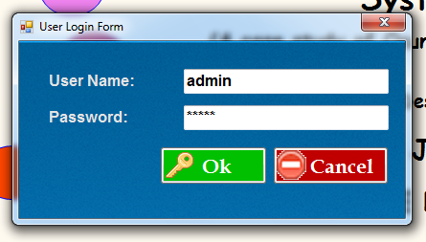

Fig 3.1 : the admin login page

**3.2.2 Pension Enrolment Form**

This is the page where the new pensioner data are collected, like full name, date of birth, gender, date of first appointment, salary structure at retirement, rank/grade level and step at retirement, current monthly pension, ministry where a pensioner retired. Then bank details are collected and then the next of kin’s details. Then their passport photograph is uploaded. At the end of registration, they will be given unique pensioner ID. The figure 3.2 shows the design view of pension enrolment form.

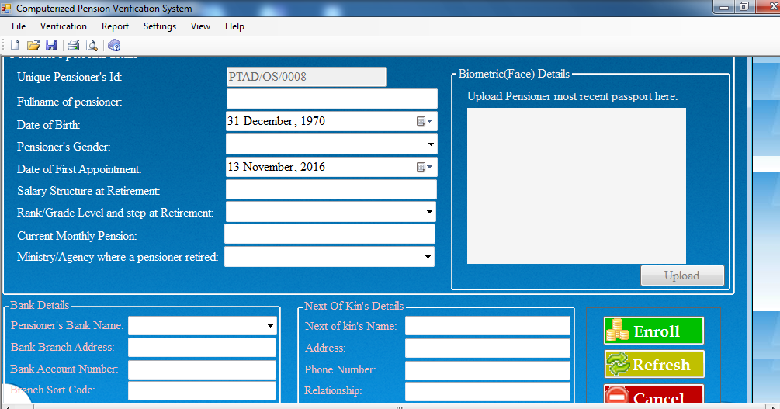

Fig 3.2 pension enrolment form

**3.2.3 Pensioner Verification form**

The pension verification form is the page where the pensioner that have already registered with a unique ID login their ID which will take them to their page. The figure 3.3 shows the design view of pension verification form.

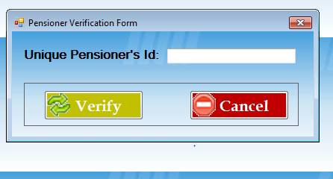

Fig 3.3 pensioner verification form

**3.2.4 Pension Monthly Verification Form**

The pension monthly verification form is the page where pensioners update their monthly payment and also verify the current month and date due for payment. The figure 3.4 shows the design view of pension monthly verification form.

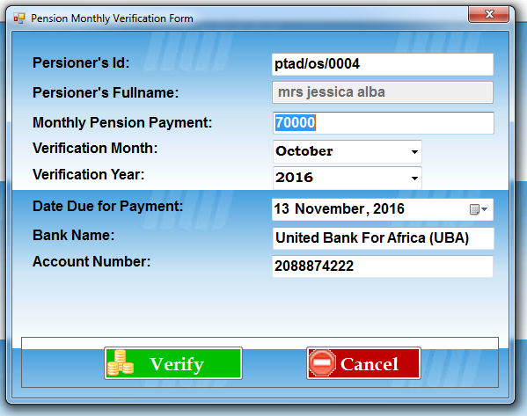

Fig 3.4 pension monthly verification form

**3.2.5 Monthly Verification Form**

The monthly verification report is where the pensioners specify the month and year they have collected their pension. The figure 3.5 shows the design view of monthly verification form.

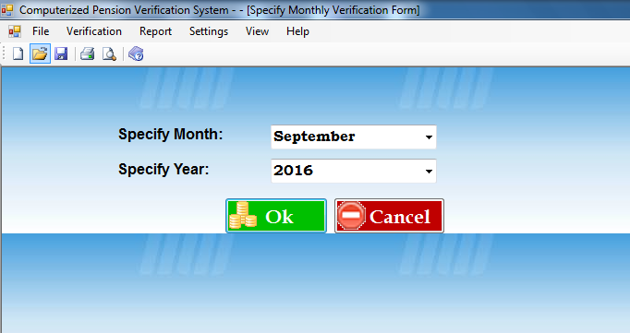

Fig 3.5 monthly verification form

**3.2.6 Pension Monthly Verification Report**

The pension monthly verification report shows each pensioner that have verified for that current month. The figure 3.6 shows the design view of pension monthly verification report.

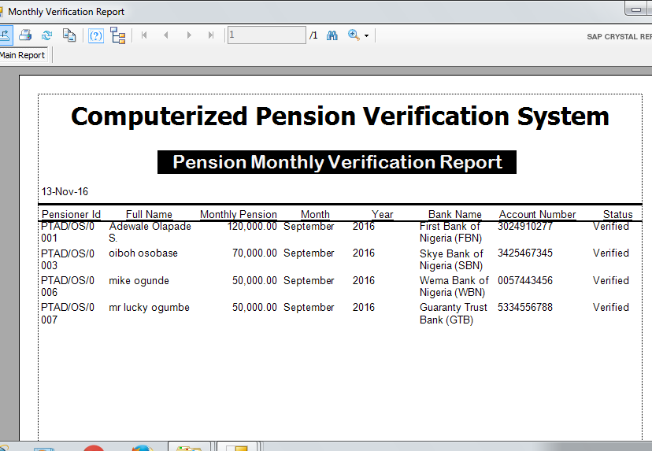

Fig 3.6 pension monthly verification report

**3.2.7 Pension Payment Information Report**

The pension payment information report shows the pension amount, arears and also the initial month and the year of the pensioner, including the account details. The figure 3.7 shows the design view of pension payment information report.

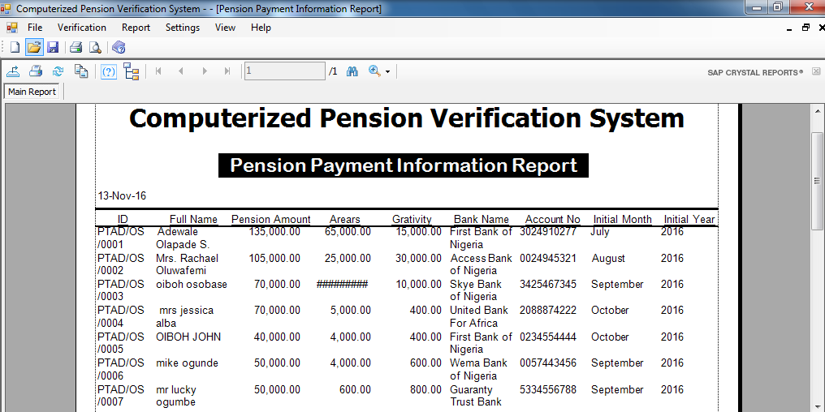 fig 3.7 pension payment information report

**3.2.8 General Pension Enrolment Report**

The general pension enrolment report is the database where all the information collected by the PFA is stored. The figure 3.8 shows the design view of general pension enrolment report.

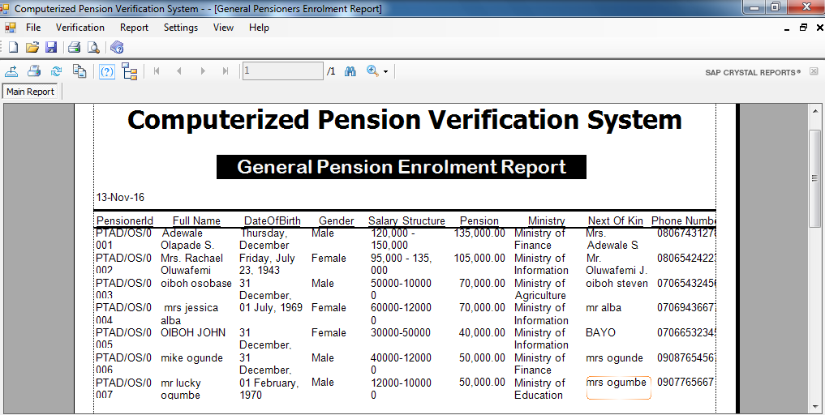

Fig 3.8 General pension enrollment report

**3.3. System Implementation**

**Programming Language Used**

The developed system was designed using Microsoft Visual Studio 2010, C#.net and Access 7. Microsoft Visual Studio 2010 is some software that could be very favored by Program Developer around the world. Microsoft Visual Studio 2010 supports an amazing array involving language, this program enables the individual to developed many applications.

C#.net is a multi-paradigm programming language encompassing strong typing, imperative, declarative, functional, generic, object oriented and component oriented programming discipline. It was developed by Microsoft within its .NET.

Access 7 is a database application developed by Microsoft.

**3.3.1** **System Evaluation**

1. Evaluation Criteria
2. Evaluation Methodology

**3.3.2. Evaluation Criteria**

The developed system based on the following criteria:

* 1. Usability
  2. Accessibility

**3.3.3. Evaluation Methodology**

The developed system was evaluated by administering questionnaires on 30 thirty users. The completely filled copies of the questionnaires were collected and used for the analysis of the result.

**CHAPTER FOUR**

**4.0.** **RESULTS AND DISCUSSION**

**4.1. Result**

The result of the evaluation of the developed system is as presented in table 4.1, and 4.2 and figures 4.1, and 4.2

**Table 4.1.** The table of responses from users on usabilty of the system.

|  |  |  |
| --- | --- | --- |
| The designed system is easy to use | Frequency (users) | Percentage |
| Strongly Agree | 26 | 80% |
| Agreed | 3 | 15% |
| Disagreed | 1 | 5% |
| Strongly Disagree | 0 | 0% |
| Total | 30 | 100% |

Figure.4.1 Graphical Representation of the responses of the users on usability

**Table 4.2.** The table of responses from the users on accessibility of the system

|  |  |  |
| --- | --- | --- |
| The designed system is easy to access | Frequency (users) | Percentage |
| Strongly Agree | 26 | 80% |
| Agreed | 3 | 15% |
| Disagreed | 1 | 5% |
| Strongly Disagree | 0 | 0% |
| Total | 30 | 100% |

Figure .4.2. Graphical Representation of the responses of the users on accessibility

**4.2. Discussion**

Table 4.1 and figure 4.1 show that 29 out of 30 users agreed that the developed system is easily usable.

Table 4.2 and figure 4.2 show that 29 users out of 30 agreed that the developed system is easily accessible.

The result presented in table showed that:

From the result it is shown that a very high percentage (95%) of the users of the developed system agreed that the system is user friendly and easily accessible.

**CHAPTER FIVE**

**5.0.** **CONCLUSION AND RECOMMENDATION**

**5.1.** **Conclusion**

In this project, a computerized pension verification system was designed and implemented using Microsoft Visual Studio 2010 and C#.net programming language. The developed system was also evaluated based on usability and accessibility.

It is concluded from the result of the evaluation of the developed system that computerized pension verification system that is capable of registering and verifying pensioners in Osun State Pension Board has been developed.

5.2. **Recommendation**

It is recommended that:

1. The developed system should be extended to provide access to registration of pensioners from other states in south western part of Nigeria.

**REFERENCE**

1. Adams, R.A. (2005): Public Sector Accounting and Finance, Lagos, Corporate Publisher Ventures.
2. Adebayo, Y.K. (2006): Essentials of Human Resource Management, Benin City, Weliscops services.
3. Adesina, M.K. (2006): The Contributory Pension Scheme: Institutional and Legal Frameworks:CBN BullionVol. No 30, No. 2 pp 1-18, january –June.
4. Ahmed, m. (2006): Meeting the Challenges of Human Capital Development in Nigeria: The Case for Reforms in our Educational Policies and System.
5. Akingbade, B. (2006): Meeting the Challenges of Human Capital Development in Nigeria:The Case for Reforms in our Educational Policies and System. Being Paper Presented by CMO of MTN, at the Alumni Convocation Lecture of the University of Nigeria, Nsuka.
6. Alo, Oladimeji (2004): Current Pension Reforms: Implications for Career Development in the Public and Private Sector, a Paper Presented at the 2ndState Conference of the Lagos State Branch of the Chartered Institute of Personnel Management of Nigeria (CIPMN).
7. Amujiri, B.A. (2009). “The New Contributory Pension Scheme in Nigeria: A Critical Assessment, NJPALG, Vol. XIV No.1, pp.137 –152.
8. Atedo,P.O.(2006): Pension Fund Administration in Nigeria: Problems and Prospects of Implementation,Undergraduate project, University of Benin.
9. Balogun, A. (2006): Understanding the New Pension Reform Act (RRA, 2004)

CBN BullionVol. No 30, No. 2.

1. Dostal, J.M. and B.H. Cassey (2007): Pension Reforms in Nigeria: How not to Learn from Others: 57th Political Studies Association, Annual Conference 11 –13 April, Bath.
2. Dhameji, S.K. and Dhameji, S. (2009). Industrial Psychology. New Delhi: S.K. Kataria and Sons.
3. Ebeguna, L.D. (2000): Financial Reporting and Analysis; Pearson Educational Inc.,Upper Saddle Rivers, New Jersey.
4. Gill, I., T Packard and J. Yermo (2005): Keeping the Promise of Social Security in Latin America, Pal Alto; CA. Stanford University Press and World Bank.
5. Kolawole, F. (2000): Capital Market Reforms: The Nigerian Experience; A paper presented at the ASEA Conference from 17-20th September, 2000.
6. Nkanga (2005): Pension Reform and the Development of Pension Systems: An Evaluation of the World Bank Assistance.
7. Ozor, E. (2006). “Review of Factors that Slow Down the Processing of Retirement Benefits.”A Paper Presented at the Workshop Organized by the Institute of Chartered Secretaries and Administration of Nigeria, Held at Modotel Enugu, between 14th and 16th May.
8. Robelo, M.F. (2002): Comparative Regulation of Private Pension Plans.
9. salami, K. (2000): Pension Reforms in Nigeria: Transition from the Defined Benefits to Defined Contribution: A Paper Presented at the IOPS Workshop in Pension Supervision in Dakar on February 5, 2000.
10. Sule, K.O. and Ezugwu, C.I. (2009): Scheme on Employee Retirement Benefits of Quoted Firms in Nigeria. African Journal of Accounting, Economics, Finance and Banking Research, 4(4), 48 –58.
11. Ugbaja, D.S. (2005). Contributory Pension.” A New Approach to Financing Pension Scheme in Nigeria”
12. Ugwu, D.S. (2006). Contributory Pension.” A New Approach to Financing Pension Scheme in Nigeria”. A Paper Presented at a Seminar Organized by Mokasha.
13. World Bank (2005): Pension Reform and the Development of Pension Systems: An Evaluation of the World Bank Assistance, Washington D.C.
14. Wuroald (2000): Rationale for Pension Reform in Nigeria; Business Day May 05.